Data Analysis Report: Movie Company Dataset

# Data Overview

* + The dataset contains information about a movie company, including variables such as gross earnings, budget, scores, votes, and writers.
  + Upon loading the data, initial exploration shows missing values in some columns.

# Data Cleaning

* + Missing data is handled by dropping rows with missing values, ensuring a clean dataset for analysis.
  + Data types are converted for numerical analysis, with budget, gross earnings, and votes converted to integer types.

# Exploratory Data Analysis

* + A graph showing a graph of a budget

    Description automatically generated with medium confidenceScatter plot analysis reveals a relationship between budget and gross earnings, indicating potential predictive power.
  + A graph with red dots and blue line

    Description automatically generatedA regression plot using seaborn confirms the positive correlation between budget and gross earnings.

# Correlation Analysis

* + 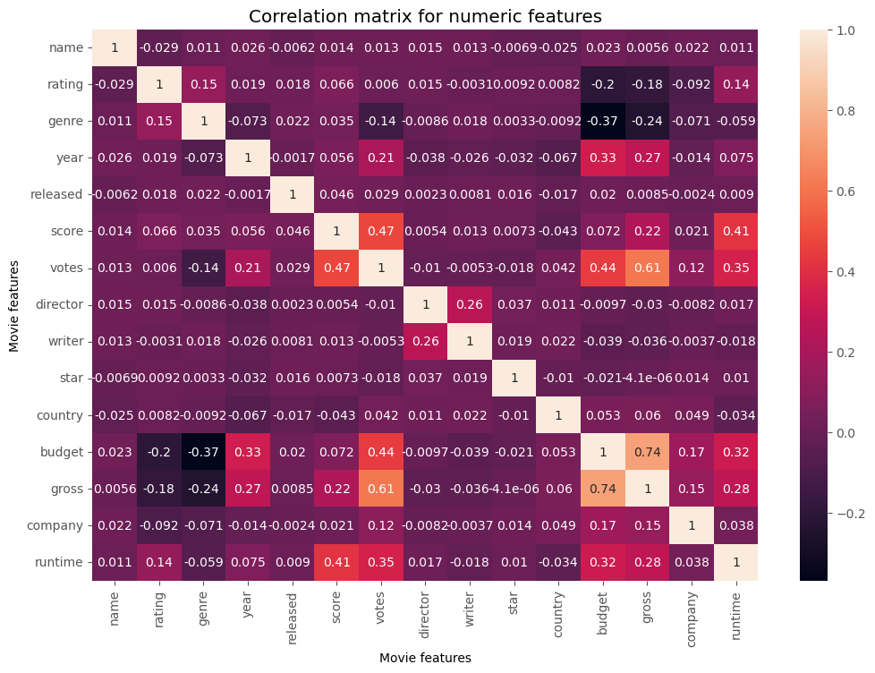Correlation analysis using Pearson correlation coefficient shows significant correlations between certain variables:

* + - The heatmap confirms key positive correlations between votes, budget, and gross earnings, vital for predicting movie financial success. It also highlights potential multicollinearity, guiding further analysis and modeling.
    - Writers show lower correlation with gross earnings compared to votes and budget, suggesting a weaker influence on earnings.

# Further Investigation

* + High correlation between votes, budget, and gross earnings warrants deeper analysis to understand the underlying factors driving these correlations.
  + Additional exploration could include analyzing trends over time, genre-specific analysis, or comparing with industry benchmarks to gain deeper insights.

# Conclusion

* + The analysis provides valuable insights into factors influencing gross earnings in the movie industry, highlighting the importance of budget allocation and audience reception (votes) in driving financial success.
  + Further analysis and contextual understanding can lead to actionable recommendations for the movie company to optimize budget allocation and improve performance.